Project: PlanaFlor: Green New Deal for nature-based economic recovery

Term of Reference - Midterm Review

PlanaFlor: Green New Deal for nature-based economic recovery"

1. Background
PlanaFlor has been executed by Fundação Brasileira para o Desenvolvimento Sustentável (FBDS) in partnership with Instituto BVRio, Fundação Getúlio Vargas (FGV), and Conservation Strategy Fund (CSF). The Project is funded by Norway's International Climate and Forest Initiative (NICFI) through the Grant Agreement –BRA-2056 BRA-21/0002. The Project started in June 2021 and is scheduled to run by December 2025.
PlanaFlor theoretical model was created based on the understanding that the Brazilian Forest Code (FC) makes one of the most potent domestic mechanisms for avoiding deforestation and protecting natural forests worldwide. If fully implemented, it has the potential of conserving over 250 million ha of native vegetation in Brazil and storing ca.100 GtCO₂.
Furthermore, the FC also provides a platform for a new macroeconomic development model based on agribusiness, forestry, and environment, revitalizing the rural economy, creating jobs, and creating a new industry of environmental services. In summary, the basis for a Brazilian "Green New Deal" for economic recovery is based on forest-based solutions.
This Project aims to develop a National Strategic Plan – PlanaFlor - to guide economic recovery and promote sustainable development focused on nature-based solutions at a landscape scale. The Project is structured in two primary outcomes: 1. Stakeholders engaged and ready to implement the PlanaFlor; 2. PlanaFlor is being implemented by federal and/or state governments and monitored by stakeholders.
The Project PlanaFlor will significantly impact protecting forests and improving lives in rural Brazil while supporting its NDC goals and implementing a law of national importance (the FC). The PlanaFlor supports constructive integration of economic production (agricultural, livestock, and forestry) with environmental objectives.

Target groups, NICF outcomes, and PlanaFlor goals
The PlanaFlor will directly benefit the following target groups:
Government agencies will benefit from a comprehensive plan, with a macroeconomic focus on solving the existing challenges preventing the full implementation of the FC and a strategic plan for sustainable rural development with the support of all sectors of the economy.
Brazil's forests and other terrestrial ecosystems avoided deforestation, native vegetation restoration, carbon storage, and economic growth in a post-pandemic recession.
Rural property owners will benefit from the potential incentives and programs that would be created to support them and facilitate compliance with the FC.
Indigenous groups, local communities, and smallholders will benefit through improved clarity and transparency regarding land tenure, rights, and access to finance and markets.

This Project is closely aligned with the strategic framework for NICFI. If fully implemented, the FC will mainly contribute to (1) reduced pressure on forests, (2) sustainable land use, (3) reduced loss of tropical forests, and (4) protection of biodiversity.
The Project falls under category 4 of the NICFI 2021-2025 Call for Proposal: Mobilizing ambition and support for forest-friendly policies. However, it also contributes indirectly, in some degrees, to the other four categories: (1) indigenous peoples and local communities, (2) deforestation-free supply chains and financial markets, (3) support for forest-friendly policies, and (5) groundbreaking ideas to reduce deforestation (many lessons to be shared with other countries).
Related to The Strategic Framework for NICFI, the Project contributes to the achievement of the following NICFI Outcomes:
1 Approved and implemented policies for sustainable forest and land use in tropical forest countries and jurisdictions (the most related).
3 Effective international incentive structures for reduced deforestation in tropical forest countries.
4 Increased transparency in land management, land use, value chains, and financing.
5 Commodity markets stimulate deforestation-free production in tropical forest countries.
6 Financial markets stimulate deforestation-free commodity production in tropical forest countries.

The overall Project outcome is to approve and implement the PlanaFlor (National Strategic Plan) for Brazil's sustainable forest and land use. Two main expected results were established to achieve this outcome:
1. Stakeholders engaged and ready to implement the PlanaFlor that involves the PlanaFlor produced and published and workshops with key stakeholders (e.g., civil society, NGOs, academia, rural producers and associations, regulatory agencies, banks);
2. PlanaFlor is being implemented by federal and/or state governments and monitored by stakeholders, involving proper structure and routines for implementation and monitoring established and documented to support government agencies.
Theory of change
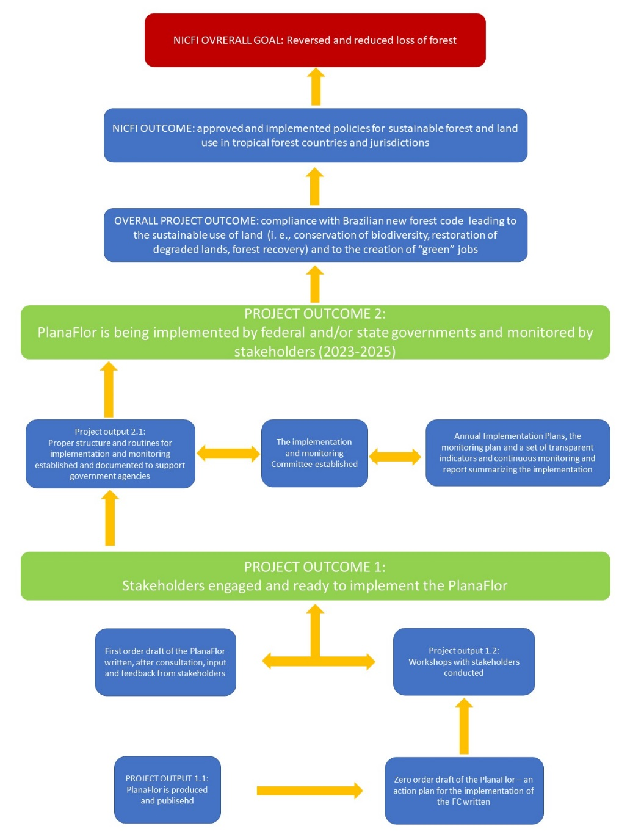
2. Objective of the review
The Midterm Review (MTR) for the Project is a requirement of the Grant Agreement between FBDS and Norad: According to article 9.1. “A review focusing on progress to date shall be carried out in the project's third year and be submitted to Norad together with a management response no later than June 1, 2024. The Grant Recipient shall draft the terms of reference for the review, based on a template developed by Norad, and submit them to the other Party for approval. The costs of the review shall be included in the Project budget”.
This ToR aims to hire a consultant to conduct the MTR for Project PlanaFlor. The MTR will assess the goals achieved, expected results, and the overall development objective of the Project. This will be done by comparing the progress made to what was initially outlined in the Project Concept document, the results framework, and the theory of change. The MTR will also focus on the objectives outlined in the Grant Agreement, the suitability of its original design; and (3) identify changes needed to ensure the achievement of its objectives and a higher level of implementation of the Project, where applicable.
In the assessment of the Project’s progress, the MTR shall be based on the following:
1. Two of the six principles for evaluation of development assistance developed by the Official Development Assistance (ODA): effectiveness and coherence.
2. NICFI Outcomes
3. NICFI 2021-2025 Areas of strategic interest, namely (1) innovation and (2) women and gender equality.

3. Review questions
The following questions should be answered in the MTR report to shed light on PlanaFlor development in different categories according to NICFI's recommendation. The answers must be based on PlanaFlor's objectives and outcomes.

Effectiveness: assessment of project progress
- To what extent is the agreement successful in achieving desired results? Please provide a separate assessment for each project-level outcome in the results framework.
- In terms of internal project adjustments, if any, what concrete recommendations do you propose to the organization for the remainder of the project cycle?
- What key successes have sprung from the agreement, and have these resulted in momentum for more outstanding project achievement?
- Were there barriers to implementing the project to what was initially proposed to Norad? To what extent has the organization adjusted its approach to meet these?
- Is there alignment of the objectives and expected results of the Project among the partner institutions?
- Are the current structure and context sufficient for continuing implementation of the Project and achieving the commitments made?
- Does the Project have weaknesses or points to be improved in its execution? If so, how could FBDS and institutional partners improve project effectiveness?
- Are the management tools and information flows in place adequate? What are the necessary adjustments to these instruments?
- Is the evaluation and monitoring of the Project by the coordination and partners adequate?

Coherence: synergies with other interventions
- Internal coherence: To what extent does the grant recipient work with or in coordination with other initiatives funded by NICFI? What are the learning points?
- External coherence: To what degree does the grant recipient seek to create alliances and foster synergies with civil society organizations and other national or international partners to ensure harmonization of interventions in the given contexts? Which points of this are positive and which are harmful? Please provide a separate assessment for each project outcome of the intervention.
- In addition to FBDS, how do partner institutions interact with other initiatives to increase PlanaFlor's capillarity and strengthen it, engaging the government and new institutions?

Contribution to NICFI outcomes:
I. Approved and implemented policies for sustainable forest and land use in tropical forest countries and jurisdictions
- How does the agreement contribute to raising the ambition for reduced emissions and the absorption of greenhouse gases in (1) the Nationally Determined Contributions (NDCs) and (2) in regional/state/province-level development strategies?
- How does the agreement contribute to protecting tropical forests and other carbon-sequestration ecosystems through regulation, legislation, and area management?
- How does the agreement promote fiscal policies that give incentives to safeguard standing forests?
- How does the agreement contribute to (1) ensuring the implementation of forest conservation within specific sectoral policies and (2) integrating forest conservation as a cross-sectoral issue in governmental policies?
- How does the agreement lead to implementing national or state-level area planning policies that promote forest-friendly rural development?
V. Commodity markets stimulate deforestation-free production in tropical forest countries
- How does the agreement contribute to adopting or implementing legal frameworks, regulations, or other initiatives affecting the commodities market to reduce deforestation? Please provide concrete examples of how such instruments can affect the market.
VI. Financial markets stimulate deforestation-free commodity production in tropical forest countries
- How does the agreement (1) prompt the withdrawal of banks and investors from projects due to deforestation risks or (2) open dialogues with such actors?
Mobilising Ambition for Forest-Friendly Policies
- How does the agreement increase forest protection or restoration support among crucial decision-makers and thought leaders?

Contribution to NICFI areas of strategic interest
- How does the agreement spur or employ innovative working methods, context analyses, partnership models, or similar innovations? Please elaborate.
- What are the impacts of the agreement, positive or negative, on women and gender equality? What are the lessons learned?

4. Scope of the review
Temporal scope. The Midterm Review should address the development of the PlanaFlor Project from its inception to the current phase to identify whether the objectives are being achieved. The consultant will also be asked to analyze whether the proposed goals are in good development to fulfill what was proposed initially. Thus, suggestions for improvements should also be suggested.
Geographic scope. The PlanaFlor project has a nationwide scope, developed through contact with Brazilian national and state government representatives and other civil society and private institutions.
Activity scope. The development of the Project should be analyzed in general, highlighting the quality of the plan developed and published and the stages of engagement with governments and institutions.

5. Main users and stakeholders
About the contracting institution
Fundação Brasileira para o Desenvolvimento Sustentável (FBDS; in English, The Brazilian Foundation for Sustainable Development) is a non-profit organization in Brazil. Its network with the scientific community, international finance agencies, and national corporations differentiates it. The organization's mission is to disseminate the best environmental and sustainability practices and influence the target audience of actors and stakeholders by generating know-how, formulating public policies, and carrying out consulting projects. Founded in 1992, the organization has almost thirty years of experience working in the areas of environmental assets, sustainable agriculture, and urban sustainability in Brazil. It makes FBDS well-positioned to lead a project that aims to develop a National Plan for implementing an integrated sustainable rural development program that reduces deforestation and GHG emissions and creates the basis for sustainable economic prosperity.

About the institutional partners
BVRio is the main partner because it has contributed to developing and implementing public policies for forest conservation and sustainable development over the last eight years, integrating efforts and assets of government agencies, civil society organizations, communities, farmers, social entrepreneurs, and corporations.
FGV is one of Brazil's most respected economics teaching and research organizations, contributing to improving public services provided to society, formulating projects and public-private partnerships, regional economic development plans, and evaluating the results and impacts of public policies.
CSF-Brazil strives to create enduring incentives for conservation by using economics to understand the trade-offs of development decisions and the benefits of sustaining natural ecosystems.

Relevant stakeholders
The PlanaFlor Project is engaging the federal, state, and other institutions of civil society and the private sector that are decisive in implementing the FC and PlanaFlor. Federal government agencies linked to the environmental and rural sectors are relevant to PlanaFlor's objectives. Although the FC is national, specific actions are attributable to the states, such as matters related to the Rural Environmental Registry (CAR). Thus, they are essential agents of engagement.
Civil society institutions linked to the environmental sector and private ones representing economic groups are essential, as they dialogue directly with rural producers, press for the acceleration of FC implementation, and influence financial credit systems. Therefore, they are relevant actors for PlanaFlor.

6. Method
Criteria for the project evaluation
Evaluating the performance of the PlanaFlor execution (effectiveness) should identify the correlation between the NICFI and the Project indicators, considering items 2 and 3 of this ToR.

Activities to be developed
The consultant hired must conduct the two activities listed below. If it is necessary to incorporate other activities to evaluate PlanaFlor, the FBDS must be consulted. Analyzes should consider qualitative and quantitative measures regarding the status of the base scenario presented for the outcome indicator achievement.
1) Data collection that involves:
a) Analysis of the Project documents: the Grant Agreement, the proposal approved, the Results Framework, the Theory of Change, the Subgrant Agreements, the annual budget, the implementation plan, the project progress reports, finalized internal and external products, minutes of meetings, engagement plan report, annual audit reports, and any other relevant documents. The main focus is to investigate data that NORAD is not able/has no access to, comparing it to the main project documentation listed above.
b) Organizing and participating in meetings and interviews (individual or collective) with the PlanaFlor team, considering the four institutional partners (FBDS, BVRIO, FGV, and CSF), and the stakeholders that have been involved in PlanaFlor implementation, for instance, representatives from federal, state and institutions, to be held in person or remotely.

2) Analyzing the implementation, review, and monitoring of the Project. With the information gathered, the consultant must systematize, analyze, and report on the successes, good practices, challenges, and recommendations for improving Project actions, considering items 2 and 3 of this ToR.
The review should be performed and presented based on documented analysis in the report, and the contractor should triangulate information from various sources.

7. Deliverable and timeline
This section describes the main products delivered in this ToR, dealines, and the payment percentage for each delivery approved and finalized. The contract will be valid for 140 days from its signing date.

Products, execution schedule, and payments
Product 1 – Work Plan defining the methodological approach
Deadline: 15 days after signing the contract
Payment: 10% of the contract
The Work Plan must contain the methodology, including the previous list of documents to be evaluated, the schedule of activities, a list of potential interviewees, and the expense forecast.
A meeting between the consultant and FBDS will be carried on presenting and agree on the objective and scope of the work and define the data and documents that the MTR must use. It will also review the expected products and decide on the content and format of the Work Plan to be developed and delivered by the consultant to the institutions responsible for the PlanaFlor. After the meeting, all the valuable documents will be made available to FBDS.

Product 2 – Report structure and data collection methodology description
Deadline: 20 days after the conclusion of product 1
Payment: 10% of the contract
The consultant will deliver a document describing the proposed structure of the MTR Report, including the strategy and script for the interviews and the final list of interviewees. This document will be presented to FBDS in a meeting, and the suggestion must be incorporated into the report structure.
Product 2 will be considered finalized and approved after the meeting, and the document will incorporate modifications.

Product 3 – First version of MTR presenting for FBDS in a work meeting
Deadline: 90 days after the conclusion of product 2
Payment: 40% of the contract
The consultant must deliver a preliminary version of the MTR Report and present it to the FBDS (and representatives of partner institutions if necessary).
Under the supervision of the FBDS, the consultant shall prepare a preliminary version of the report containing the first results found from collecting and systematizing the information from documents and interviews. This report requires the contractor to collect and organize data from documentation, research, and interviews with technical experts from FBDS, institutional partners, and key stakeholders.
The product will be considered finished when the contracting party makes the relevant modifications and adjustments after meeting with FBDS.

Product 4 – Final Report of MTR
Deadline: 15 days after the conclusion of product 3
Payment: 40% of the contract
The final MTR Report should contain the analysis of the data gathered and recommendations for improving the implementation of the PlanaFlor.
This stage of the contract includes a presentation of the draft final report to FBDS (if necessary, to the institutional partners and NICFI), suitability of the document after the meeting, and delivery of the final report along with an Executive Summary containing the Summary of the MTR.
The consultant has to present the main results to the PlanaFlor coordinators (and NICFI if necessary).

The preliminary and final versions of the report must be made available in an online folder shared with the designated FBDS as a condition for payment.
FBDS shall certify the compliance of the delivery of the products about the conditions established in this ToR and shall decide on the approval, correction, or rejection of the documents within 10 (ten) working days after receipt.
Suppose FBDS requests a correction to a product. In that case, the consultant must deliver that corrected version within 5 (five) working days from the ordered date or within a more extended period if expressly justified by the contractor and agreed on with FBDS.
The non-correction of the products or non-compliance with the conditions established in this ToR may lead to the unilateral rescission of the contract.
The consultant will present the products or meet with the NICFI whenever there is a request from Donnor.

Formats to deliver products
The report should not surpass 30 pages, excluding annexes. It shall consist of an executive summary, a main body covering the project's background, the purpose and objectives of the review, the findings, conclusions, and recommendations for our specific project to draw lessons for project continuation. Please also include an annex that lists all the sources used (documents, interviewees, others).
All the products (1 to 4) must present a level and language compatible with their destination. They will be given in English (a report version in Portuguese is also encouraged), A4 double-spaced paper in digital format, Word for Windows, updated to version 16 or higher, and compatible with Microsoft Office/Microsoft 365.
The specifications, drawings, designs, originals, material, files and computer programs, reports, and other documents prepared by the contractor in the execution of the object of this ToR will belong to the contractor. They will be delivered to it before the date set for the end of the contract.
The consultant may retain a copy of the products indicated above. Still, their use for purposes other than the object of this instrument will depend on the FBDS's prior and express authorization, even after the contract is terminated.
The consultant must formally present the final results of the MTR to the FBDS, institutional partners, and NICFI.

Additional obligations of the consultant
The consultant must provide information about the progress of the activities whenever requested by FBDS or NICFI.
All activities must be articulated with the FBDS. Whenever necessary, the consultant must update FBDS on the progress and execution of actions and changes in their development.
By submitting a proposal for this ToR, the applicant certifies that they have not been associated with the design and implementation of the PlanaFlor in any way that might compromise their independence and impartiality concerning the results and performance of the Project. In addition, they certify that they will not have any future interests (within six months of contract completion) in the Project execution or implementation units.
The consultancy must be developed under the supervision of FBDS, which will indicate a technician responsible for monitoring the work produced by the consultant to support, implement and supervise the actions to be implemented, as well as to receive, analyze and approve the products received together with the NICFI if it seems necessary.
When requested, the consultant will make available to FBDS all the information gathered necessary for the Project evaluation process so that it can monitor the activities and verify the preparation of the products.

Necessary inputs
The consultant must perform the work using its technical collection and material, as well as the location for performing the services and inputs necessary for satisfactory performance of the services agreed upon.
All expenses related to social security, labor, and insurance charges, as well as any other fees and costs, must be included in the proposal and borne by the contractor.
The consultant must have the necessary equipment, tools, and consumable items to perform the activities related to these terms (e.g., computers, cameras, software licenses), which will be the contractor's responsibility.
Expenses related to travel for visits and interviews must be included in the applicant's financial proposal.

Qualifications and experience of the applicant – mandatory requirements
To perform this MTR, the consultant must have at least the following minimum qualifications (eliminatory):
a) Be a legal entity with an active registration.
b) Have professionals with university degrees on its technical staff who will perform the work and at least five years of experience by the legal entity in preparing, implementing, monitoring, and reviewing Projects.
Other desirable knowledge and experience (qualifying):
a) Experience in monitoring and reviewing projects related to the themes: conservation of biodiversity, development and implement public policies (primarily environmental policies), and sustainable agriculture development.
b) Professionals with experience in managing projects.
c) Experience in monitoring and reviewing institutional arrangements and with the application of tools for assessing management effectiveness;
b) Experience with monitoring and reviewing projects funded by Norad and NICFI.

Evaluation criteria
13.1 The technical evaluation will cover the institutional and professional's qualifications and the technical proposal and will be conducted by FBDS, considering the following criteria:
Experience required | Score | Points
 |  | Maximum
Monitoring Norad and/or NICFI-funded projects | 5 points/Project | 15
Professionals with a background in project management | 2 points/profissional | 10
Monitoring projects with international donors | 5 points/project in the last 5 years | 15
 | 3 points/project over 5 years
Monitoring and reviewing Projects in relevant subjects | 5 points/project in environment public policies | 30
 | 4 points/Project in public policies
 | 3 points/project in conservation biodiversity
 | 3 points/Project in sustainable agriculture development
Evaluation of Institutional Arrangements | 2 points/job | 10
Experience with tools for assessing management effectiveness | 5 points/job | 20
Total |  | 100

Applicants must present supporting documentation of the exposed criteria so the FBDS team can analyze their veracity. It should include certificates of technical capacity, statements from previous clients, contracts, reports, and other relevant documents supporting the proposal's information. The documentation should include a detailed description of the services or activities performed and the exact work period indicated in years.
Work performed as part of an undergraduate or graduate degree requirement will not be considered professional experience, nor will volunteer work.
In case of a tie, FBDS reserves the right to use other complementary criteria related to the scope of the contract.

8. Proposal application
The proposing entity must submit a technical and financial proposal to perform all the activities and products described in this ToR.
The Technical Proposal must be sent as a file (.pdf) and contain the methodology to be developed for each activity, supported by bibliographic references or recognized methods.
The Financial Proposal must be sent in a file (.pdf) and signed by the applicant entity, stating the costs per product, as described in item 7, and the total amount for this consulting service in Brazilian Reais (BRL).
The proposal must include documentation that provides evidence of the proposing entity and professional experience in compliance with item 13.
The applicants must submit their Technical Proposal and Financial Proposal by email to rafaelasilva@fbds.org.br. The email's subject line should be "PLANAFLOR Midterm Review - THE NAME OF THE APPLICANT". The deadline for submission is September 30, 2023.

If you have any questions about this ToR, don't hesitate to contact Rafaela Silva at rafaelasilva@fbds.org.br

